Technology and Architecture 2

TOGAF (Open Group Architectural Framework) 2

ETL design 2

SOA (Service Oriented Architecture) 2

JSON (JavaScript Object Notation) 2

Zachman Framework for Enterprise Architectures 3

Content Management (IBM ECM, OpenText ECM and MS SharePoint) 3

Microsoft's SharePoint 2010 3

Active Server Pages (ASP) 3

AJAX 3

Spring 3

BizTalk 3

BizTalk and Websphere 4

J2EE and EJB 4

NET Architecture 4

Mobile 5

SCOTIA Mobile 5

Mobile-enabled architecture 5

Native mobile application 5

Web-based mobile application 5

TANGO Mobile Architecture 5

MICROSOFT Mobile Architecture 5

Corporate security 5

Mobile security history 6

Third-Party management solutions 6

MICROSOFT ERP 6

MS Excel 7

Models 7

Functions 7

Wealth Management 9

Components of Wealth Management Technology 9

Wealth Management Value Chain 9

Schroders IT 9

Credit Card 10

CRM 10

HR Process and System 11

Online brokerage 11

ORACLE ERP Implementation Methodology 11

COBIT 5 12

COBIT 5 Principles 12

Governance & Management 12

Goals cascade 12

Process for Governance 13

Enablers 13

Enablers: Generic 13

Seven Phases of Implementation 14

COBIT 5 Process Capability Model 14

Risk Scenario Structure 15

Risk Model 15

IT Risk in the Risk Hierarchy 16

Risk Map and Risk Appetite 16

Risk IT Principles 16

Elements of Risk Culture 16

IT Risk Scenario Components 16

Risk Analysis & Response 16

IT Risk Register 16

Risk Scenarios Template 18

CRISC 5 Practice Domains 18

Domain 1—Risk Identification, Assessment and Evaluation 18

Domain 2—Risk Response 18

Domain 3—Risk Monitoring 18

Domain 4—Information Systems Control Design and Implementation 18

Domain 5—IS Control Monitoring and Maintenance 19

Information Security Management 19

SABSA Security Matrix 19

Defense in depth by Function 19

Enterprise Architecture 20

TOGAF 9 Content Overview 20

Architecture Development Method (ADM) 20

Program Management Process (Ricardo Vargas) 21

Traceability Matrix 21

Benefits Realization 21

Managerial Tools, Techniques 22

Constraint Analysis 22

Cause and Effect 22

Tornado Diagram 22

Check list 23

Influence Diagram 23

Root Cause Analysis 23

Probability and Impact Calculation 23

Probability and Impact Matrix 23

FMEA Diagram 23

Fault Tree Analysis 23

Risk Breakdown Structure 23

Decision Tree 23

Risk Heat Map 23

DMAIC Tools Map 24

# Technology and Architecture

#### TOGAF (Open Group Architectural Framework)

⬩Framework for enterprise architecture for designing, planning, implementing, and governing enterprise information architecture ⬩**4 levels B,D,A,T:** Business, Application, Data, Technology 🞟**Architecture Development Method (ADM)** **9 Phases 🄌**Preliminary Phase ➊ Requirements Management ➋Phase A:Architecture Vision ➌Phase B:Business Architecture ➍Phase C:Information Systems Architectures ➎Phase D:Technology Architecture ➏Phase E:Opportunities & Solutions ➐Phase F:Migration Planning➑Phase G:Implementation Governance ➒Phase H:Architecture Change Management ⬩Relies heavily on modularization, standardization and proven technologies/ products. See **TOGAF 9**

#### ETL design

**Guidelines** ➊Performance ➋Simplicity ➌Repeatability ➍Modularity ➎Reusability ➏Xtensibility ➐ Revocability ➑Subject-orientation ➒Auditability **Procedures** ➊**Report rqmts** (functions, data , security , test plan) ➋**Design Review** (ETL rqmts, report data model, limits) ➌**Data model** (logical, physical) ➍**ETL Development** (tech rqmts, ETL maps + sessions) ➎**DBA Optimization /Security** ➏**Development** ➐ **Unit Test** / **QA** ➑**System Test** (performance) ➒**Functional Test** (users test data, security, performance, function) ➓**Production** **ETL Tools** ➊Oracle warehouse builder ➋BO Data integrator ➌SAS data integrator ➍IBM Information server ➎INFORMATICA PowerCenter ➏MSFT SQL Server Integration services SSIS

#### SOA (Service Oriented Architecture)

**S**et of principles & methodologies for designing and developing software in the form of interoperable services. These services have well-defined business functionalities that are built as software components (discrete pieces of code and/or data structures) which can be reused for different purposes. SOA design principles are used during the phases of systems development and integration. SOA generally provides a way for *consumers of services*, such as web-based applications, to be aware of available SOA-based services**. XML** and **JSON** are often used for interfacing with SOA services. SOA defines how to integrate widely disparate applications for a Web-based environment and uses multiple implementation platforms. Rather than defining an API, SOA defines the interface in terms of protocols and functionality. An endpoint is the entry point for such a SOA implementation. Service-orientation requires loose coupling of services with operating systems and other technologies that underlie applications. SOA separates functions into distinct units, or services, which developers make accessible over a network in order to allow users to combine and reuse them in the production of applications. These services and their corresponding consumers communicate with each other by passing data in a well-defined, shared format, or by coordinating an activity between two or more services. SOA can be seen in a continuum, from older concepts of distributed computing and modular programming, through SOA, and on to current practices of mashups, **SaaS**, and **cloud computing** (which some see as the offspring of SOA)

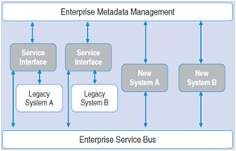

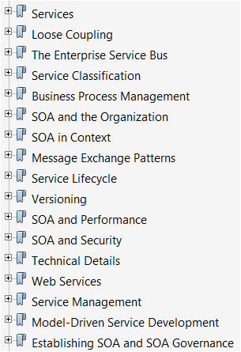

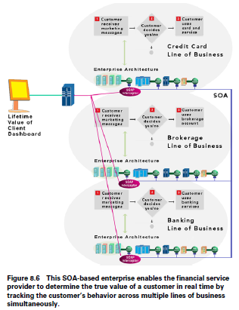

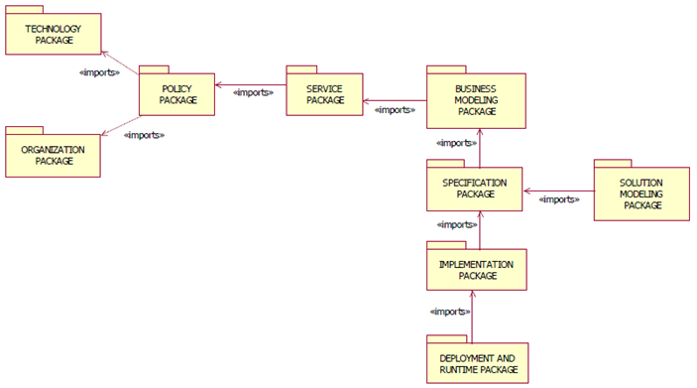

#### JSON (JavaScript Object Notation)

**T**ext-based open standard designed for human-readable data interchange. It is derived from the JavaScript scripting language for representing simple data structures and associative arrays, called objects. Despite its relationship to JavaScript, it is language-independent, with parsers available for many languages. The JSON format was originally specified by Douglas Crockford, and is described in RFC 4627 . The official Internet media type for JSON is *application/json*. The JSON filename extension is *.json*. The JSON format is often used for serializing and transmitting structured data over a network connection. It is used primarily to transmit data between a server and web application, serving as an alternative to XML. It is promoted as a low-overhead alternative to XML as both of these formats have widespread support for creation, reading and decoding in the real-world situations where they are commonly used.[33] Apart from XML, examples could include OGDL, YAML and CSV. Also, Google Protocol Buffers can fill this role, although it is not a data interchange language.

#### Zachman Framework for Enterprise Architectures

**Contextual** (Why) Goal List – primary high level organization goals (How) Process List – list of known processes (What) Material List – list of known organizational entities (Who) Organizational Unit & Role List – list of organization units, sub-units, and identified roles (Where) Geographical Locations List – locations important to organization; can be large and small (When) Event List – list of triggers and cycles important to organization

**Conceptual** (Why) Goal Relationship Model – identifies hierarchy of goals that support primary goals (How) Process Model – provides process descriptions, input processes, output processes (What) Entity Relationship Model – identifies and describes the organizational materials and their relationships (Who) Organizational Unit & Role Relationship Model – identifies enterprise roles and units & relationships between them (Where) Locations Model – identifies enterprise locations & relationships between them (When) Event Model – identifies/ describes events and cycles related by time

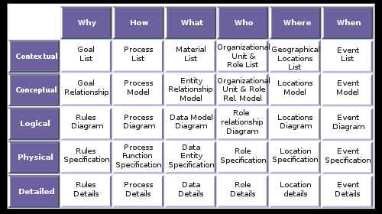

**Logical** (Why) Rules Diagram – identifies and describes rules that apply constraints to processes and entities without regard to physical or technical implementation (How) Process Diagram – identifies and describes process transitions expressed as verb-noun phrases without regard to physical or technical implementation (What) Data Model Diagram – identifies and describes entities and their relationships without regard to physical or technical implementation (Who) Role Relationship Diagram – identifies and describes roles and their relations to other roles by types of deliverables without regard to physical or technical implementation (Where) Locations Diagram – identifies and describes locations used to access, manipulate, and transfer entities and processes without regard to physical or technical implementation (When) Event Diagram – identifies and describes events related to each other in sequence, cycles occur within and between events, without regard to physical or technical implementation

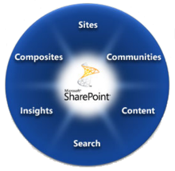**Physical** (Why) Rules Specification – expressed in a formal language; consists of rule name and structured logic to specify and test rule state (How) Process Function Specification – expressed in a technology specific language, hierarchical process elements are related by process calls (What) Data Entity Specification – expressed in a technology specific format; each entity is defined by name, description, and attributes; shows relationships (Who) Role Specification – expresses roles performing work and workflow components at the work product detailed specification level (Where) Location Specification – expresses the physical infrastructure components and their connections (When) Event Specification – transformations of event states of interest

**Representation** cells with detailed representation give Rules detail for (Why); Process detail for (How); Data detail for (What); Role detail for (Who); Location detail for (Where); Event detail for (When).

#### Content Management (IBM ECM, OpenText ECM and MS SharePoint)

The core function of CM systems is to present information on web sites. CMS features vary widely from system to system. Simple systems showcase a handful of features, while other releases, notably enterprise systems, offer more complex and powerful functions. Most CMS include Web-based publishing, format management, revision control (version control), indexing, search, and retrieval. The CMS increments the version number when new updates are added to an already-existing file. A CMS may serve as a central repository containing documents, movies, pictures, phone numbers, scientific data. CMSs can be used for storing, controlling, revising, semantically enriching and publishing documentation.

#### Microsoft's SharePoint 2010

Refers to the "SharePoint Wheel" to help describe what SharePoint's tools can facilitate inside organizations. The wheel refers to six outcomes: **Sites**: contextual work environment. Once SharePoint is configured, these sites can be created without any requirement for specialized knowledge. A context for a site may be organization-wide, or it may be specific to an individual team or group; **Communities**: places where communication and understanding happens. Communities can occur around any context, and will typically develop around either shared knowledge, or shared activities (such as collaboration); **Content**: SharePoint provides management of documents and work items that need to be stored, found, collaborated on, updated, managed, documented, archived, traced or restored - in accordance with relevant compliance or governance policies; **Search**: Look for relevant communities, content, people, or sites: search is based on keywords, refinement, and content analysis; **Insights**: Information from any part of the organization can be surfaced inside useful contexts, providing information that can improve effectiveness; **Composites**: SharePoint enables no-code integration of data, documents and processes to provide composite applications ("mash-ups" based on internal data).

#### Active Server Pages (ASP)

Also known as Classic ASP or ASP Classic, was Microsoft's first server-side script engine for dynamically generated web pages. Initially released as an add-on to Internet Information Services (IIS) via the Windows NT 4.0 Option Pack (ca. 1996), it was subsequently included as a free component of Windows Server (since the initial release of Windows 2000 Server). ASP.NET has superseded ASP. ASP 2.0 provided six built-in objects: Application, ASPError, Request, Response, Server, and Session. Session, for example, represents a session that maintains the state of variables from page to page. The Active Scripting engine's support of the Component Object Model (COM) enables ASP websites to access functionality in compiled libraries such as DLLs. ASP 3.0 does not differ greatly from ASP 2.0 but it does offer some additional enhancements such as: Server.Transfer method, Server.Execute method, and an enhanced ASPError object. ASP 3.0 also enabled buffering by default and optimized the engine for better performance. The use of ASP pages with Internet Information Services (IIS) is currently supported on all supported versions of IIS. The use of ASP pages will be supported on Windows 8 for a minimum of 10 years from the Windows 8 release date.[2]

#### AJAX

An acronym for Asynchronous JavaScript and XML is a group of interrelated web development techniques used on the client-side to create asynchronous web applications. With Ajax, web applications can send data to, and retrieve data from, a server asynchronously (in the background) without interfering with the display and behavior of the existing page. Data can be retrieved using the XMLHttpRequest object. Despite the name, the use of XML is not required (JSON is often used instead), and the requests do not need to be asynchronous.[2] Ajax is not a single technology, but a group of technologies. HTML and CSS can be used in combination to mark up and style information. The DOM is accessed with JavaScript to dynamically display, and to allow the user to interact with the information presented. JavaScript and the XMLHttpRequest object provide a method for exchanging data asynchronously between browser and server to avoid full page reloads.

#### Spring

Was an experimental microkernel-based object oriented operating system developed at Sun Microsystems in the early 1990s. Using technology substantially similar to concepts developed in the Mach kernel, Spring concentrated on providing a richer programming environment supporting multiple inheritance and other features. Spring was also more cleanly separated from the operating systems it would host, divorcing it from its Unix roots and even allowing several OSes to be run at the same time. Development faded out in the mid-1990s, but several ideas and some code from the project was later re-used in the Java programming language libraries and the Solaris operating system.

#### BizTalk

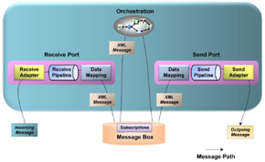

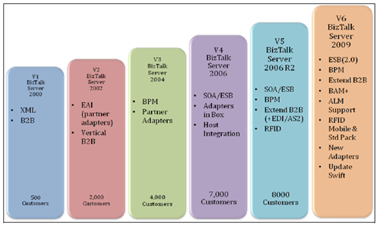

#### BizTalk and Websphere

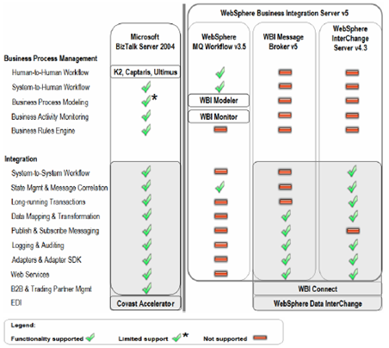

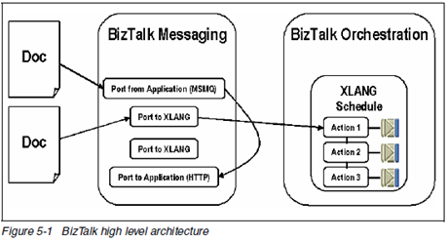

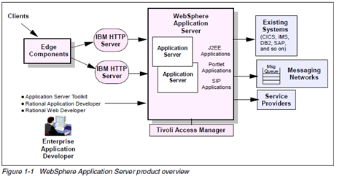

#### J2EE and EJB

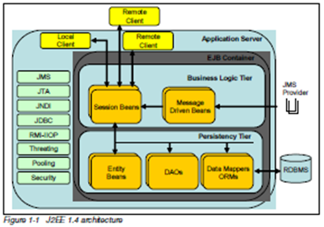

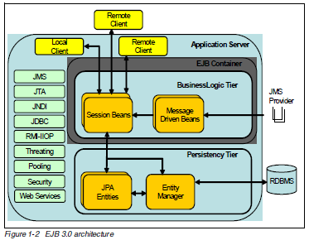

#### NET Architecture

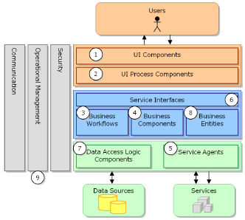

## Mobile

#### SCOTIA Mobile

#### Mobile-enabled architecture

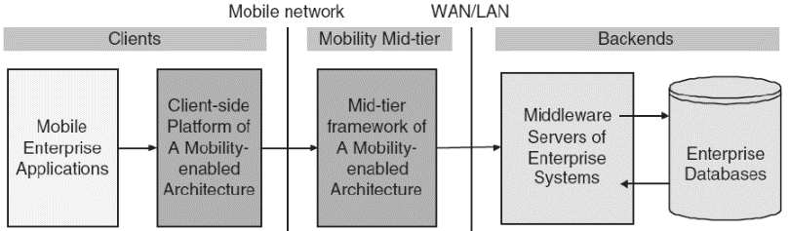

#### Native mobile application

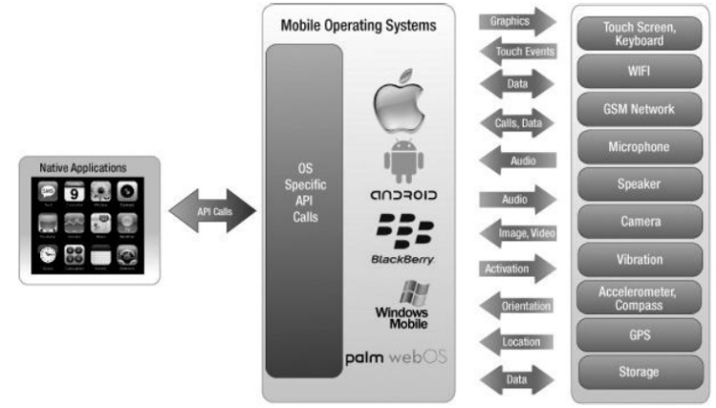

#### Web-based mobile application

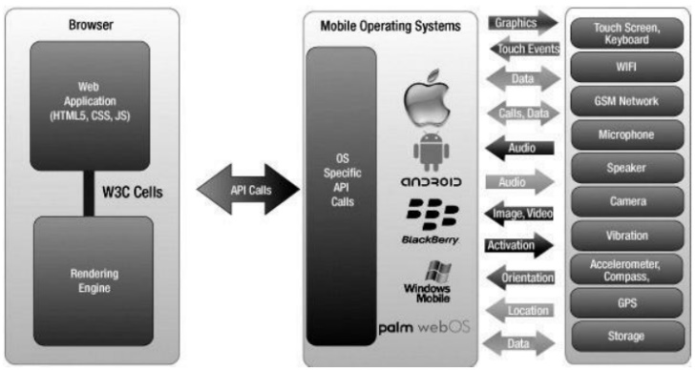

#### TANGO Mobile Architecture

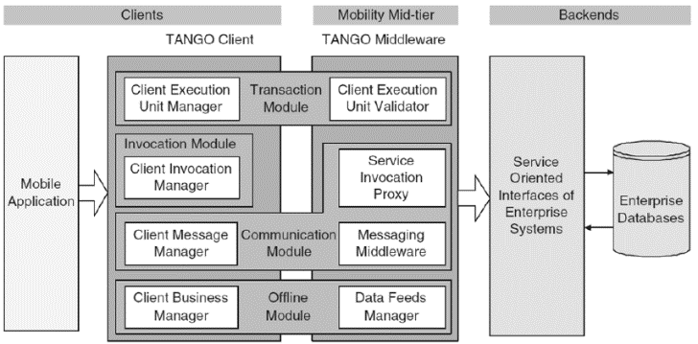

#### MICROSOFT Mobile Architecture

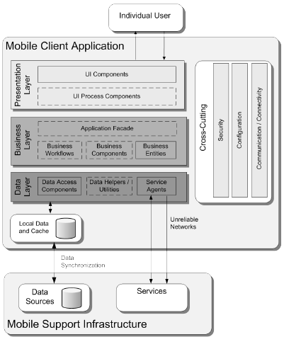

#### Corporate security

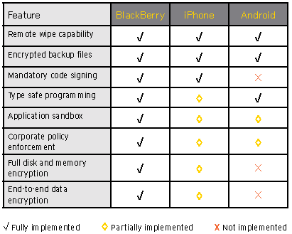

#### Mobile security history

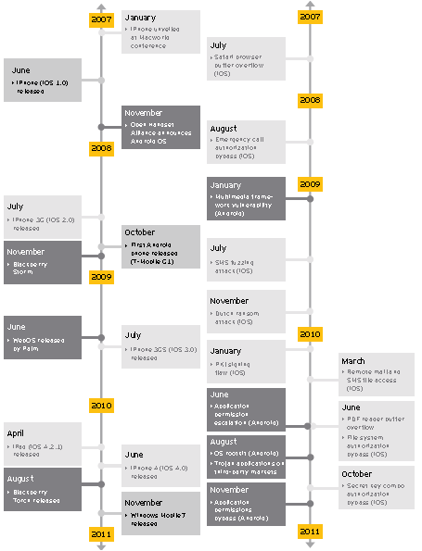

#### Third-Party management solutions

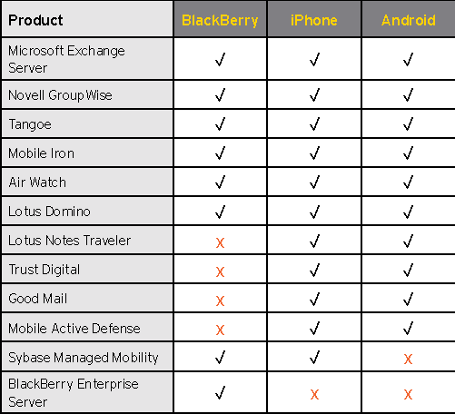

## MICROSOFT ERP

|  |  |
| --- | --- |
| **General Ledger**  • Flexible accounting periods, year-end procedure including a closing sheet  • Configurable journals with approval  • Recurring journals  • Posting control with pre-validation  • Multicurrency + exchange adjustment  • Multiple structured budget  • Different Tax calculation & reporting  • Financial statement alternative rows  • Simpler chart of accounts with dimensions  • Allocation based on % for accounts  **Advanced General Ledger**  • Transactions across companies with intercompany accounting functionality  • Project transactions using cash flow forecasting and currency requirement  • Consolidate financials for multiple companies online or data exports/imports  • Redistribute amounts according to predefined setups of accounts, dimensions, and percentages  • Control and constrain financial  dimensions combination  **Fixed Assets Management**  • Life cycle from acquisition to depreciation and disposition  • Projects transferred as fixed assets for capitalization and depreciation purposes  • Maintain asset status information  • Multiple depreciation models  • Forecasts using fixed-asset budgets  • Integrated to purchasing and inventory  • Barcode handling  **Bank Management**  • Bank account reconciliation, including  electronic bank account statement  import (for selected countries)  • Check setup  • Monitoring deposits, payments, drafts,  and bank balances  • Import of back account statements  **Accounts Receivable**  • Monitor credit checks  • Terms of payment, advanced schedules and cash discounts  • Prepayment capabilities  • Draft handling (bill of exchange)  • Payment proposal  • Text invoicing (non-inventory item)  • Collection letter & interest calculation  • Payment journal with proposal features  • Multicurrency + exchange rate adjustment  • Export/import electronic payments  **Accounts Payable**  • Bridging accounts  • Terms of payment, advanced schedules and cash discounts  • Prepayment capability  • Promissory note handling  • Proposal feature with flexible payment  • Invoice entry options, handling approved / unapproved invoices, matching invoices to physical deliveries  • Payment journal with payment proposal  Dimensions Dept-Cost center-Purpose  • Values applied and stored at transaction  • Data aggregated by dimensions  • OLAP cubes use dimensions  • Rules on accounts for postings to GL  • Default dimensions set on base data, such as ledger and customer accounts  • Dimension hierarchies set up to control the posting of dimensions  **Sales/Trade**  • Initiate purchase orders from production/ sales orders, or inventory coverage rules  • Purchase orders with direct link  to sales orders for JIT purchase  • Comprehensive price calculations  • Quick entry of order lines  • Misc. charges to item costs and sales/purchase prices  • R-T currency conversion on open orders  • Compare costs against revenue  • Create credit notes from invoice journals  • Print **cash on delivery (COD)** documents when invoicing and follow up  • Reconciliation of inventory values versus ledger transactions  • Support for direct delivery  • Convert purchase units into inventory handling units, or convert inventory handling units into sales units  • Print backorder information on delivery  documentation and invoices  • **Costing methods**: first in/first out  (FIFO), last in/first out (LIFO), standard  cost, and weighted average  Radio frequency identification (RFID)  • Read/write to RFID-EPC (RFID-electronic  product code) tags  • Register pallets and inventory items and  control them throughout the supply chain  • Interface with RFID devices  **Logistics Forecasting**  • Enter/ edit sales & purchase forecasts  • Use item and period allocation keys to  allocate forecasts to items & time periods  • Consolidate sales & purchase forecasts into one inventory forecast  **Logistics Item Dimensions**  • Describe up to 3 item dimensions: configuration, size, and color  • Rename the size and color dimensions  to suit your specific business needs  • Set up specific prices and discounts per  item dimension combination  **Logistics Storage Dimensions**  • Storage by individual warehouse  • Track with serial/ batch number  Logistics On-Hand Tracking  • On-hand inventory per warehouse  • Drill down to current on-hand situation  • Track batch and serial numbers throughout **Quarantine Management**  • Set aside items in quarantine using  quarantine orders, either manually or  automatically, when receiving items  • Look up quarantine inventory in the quality control process **ABC Analysis**  • Calculate the **ABC analysis** based on  revenue, cost, margin, and carrying  costs, or with user-defined limits  **Logistics Bills of Material (BOM)**  • Maintain multiple barcodes per item  • Maintain multi-level BOMs, with version  and date control of multiple BOMs  • Approval routing  • Calculate variable/constant consumption  • Support phantom BOMs  • Make allowances for scrap in the  consumption calculation  • Where-used feature  • BOM explosion for materials planning  and pricing calculation on all BOM levels  • Dependent BOM versions  **Logistics Placement and Storage**  • Different location/ storage policies at warehouse level and item level  • Specify warehouse locations on 5 levels: warehouse, aisle, rack, shelf, bin  • Improve accuracy with RFID capabilities  Graphical BOM Designer  • Graphical suite for designing and  maintaining BOMs and gaining insight  into existing BOMs  • All levels and sub-levels of the BOM are  visible in a graphical tree structure  • Drag items from inventory table to BOM  • Drag items from BOM to route operations  • Circulation check to control which functions on certain BOMs  • System alerts notify when a BOM is active  and should not be modified  **Logistics Inventory Dimensions**  8 different dimensions to specify exact location of items in inventory identification:  • Physical location: warehouse, location,  and pallets  • Item origin: serial number, batch number  • Characteristics: configuration, size, color  **Logistics Arrival Journals**  • Use-for item registration  • Make items available in inventory  immediately after posting arrival journal  • Have the option of either manual or  automatic suggestion of arrival and  output locations according to storage  and item setup | **Logistics Barcode Support**  • Maintain multiple barcodes per item  • Read/write 4 types of barcodes: **EAN128/**  UCC128, Code 39, Interleaved 2 of 5,  Code 128  **Logistics Pick and Shipments**  • Send electronically **advanced**  shipping notification (ASN) to receiver  • Specify that shipments are sales order–  specific or customer-specific  **Different Pallet Types**  • Create pallet transports from order types: input, output, or refill orders  • Prioritize according to order types  • Consider different pallet types for different sizes when selecting locations  • Use RFID to register the pallets and  inventory items, and control them  throughout the supply chain  **Project Management**  To track time and materials consumed and follow up on time and material projects and internal projects. Itemize time and materials for invoicing, while retaining sales prices and cost of items and man hours.  **Registration and Data Entry**  • Itemize project costs, employee hours,  materials used, and fees incurred by the  customer and enter them into the journal  • Enter hours remotely over the Internet  with Enterprise Portal  • Create your own project hierarchy  • Follow up on status of deliveries and sales  and purchase orders  **Invoicing**  • Invoice project/project group, retain itemized time and resource costs  • Sub-projects invoiced separately or together: single project with multiple invoices for different customers  • Approval sign off procedures for Invoices,  • Prepayments tracked / applied to future invoices  • Project costs direct into accounts payable or purchase orders  • Flexible-line property for chartable and non-chartable costs  • Adjust transactions before creating  your invoice proposals, and edit invoice  proposals before final invoicing  **Project Management**  • Break down the time and materials  used on projects and assign individual  hours or items to sub-projects for  more detailed control of costs and  consumables  • Project structures saved so that budgets, sub-projects, and activities can be copied from previous projects and applied as a template to new projects  • Schedule tasks and allocate resources  and capacity to future tasks  **Accounting**  • Tightly integrated with general ledger functionality, so that dimensions can be applied to every transaction in a project  • Detailed posting profiles for transactions to be posted to specified ledger accounts depending on preset criteria  **Inquiry and Reporting**  • A statistic form compares project  budgets to consumption over time  • General ledger integration makes it  easy to follow transaction details for a  single project or group of projects  **Communications Management**  • Campaigns based on sales & comm. and demographic information  • Communication tasks to sales/marketing based on responsibilities/ specializations  • Marketing campaign activities based on company-defined policies  • Link campaigns, questionnaires, projects,  and Web responses  • Divide campaigns into sub-campaigns to  reach more specific audiences  • Campaign linked to a project  • Broadcast campaigns via e-mail, Web,  fax, mail, and phone  • Use existing campaign structures as  templates for new campaigns  **Marketing Encyclopedia**  • Common repository for all of your sales  and marketing collateral  • Exchange sales and marketing knowledge  • Review sales material such as information  on product lines, products, and price lists  • Categorize sales and marketing materials  (product line, white papers, graphics, Web  sites, and videos) for quick access  • Access information in the encyclopedia,  which supports Web links, audio/video  clips, presentations, and graphical software  • Track and review competitor information  and trends with competitor Web sites  **Telemarketing**  • Create call lists based on contact data  • Telephones dial automatically  • Telemarketing activities based on company-defined policies  • Integrate campaigns and call list  • Integrate questionnaire in sales process  • Build custom call scripts to guide staff through phone call interactions  • Telemarketing window contains information your marketing and customer support specialists need on their calls  • Computer Telephone Integration  (CTI) via Telephony Application  Programming Interface (TAPI)  • Full call logging that includes time,  date, duration, caller, and more  • Extract customer groups and allocate  responsibility for calls to these groups  across your telemarketing or phone  support staff  • Analysis tools measure employee  performance and call statistics  **Contact Management**  • Store information on prospects,  customers, vendors, business contacts  • Register activities associated with the  sales process  • Synchronize activities as appointments  and tasks with Outlook  • Configurable mapping of Microsoft  Dynamics AX fields to Outlook  • Data protection in Outlook  synchronization process  • Drag files, documents, and e-mail  messages from Windows Explorer and  Outlook into the document handling  system of Microsoft Dynamics AX  • Log transactions on selected records  • Import prospects with business and  contact details  • CTI using TAPI  • Send e-mail and Short Message Service  (SMS) messages to individuals or groups  • Track all additions, changes, and deletions to contact and sales process information performed by your sales staff  • Track all mail, telephone, and e-mail  communications between sales staff and  the outside world  • Generate and record communications to  groups of customers based on selected  criteria applied to customer data  **Sales Process Management**  • Generate leads by importing them  from external sources, then allocate  responsibility for leads to your sales staff  and track the quality of leads  • Extend offers to groups of leads, based  on customized profiles  • Full integration with other parts of  Microsoft Dynamics AX gives you easy  access to sales-related information  • Product, project, and financial data, such as manufacturing cost, item availability, and delivery time can be available to sales staff  • Sales quotations are extended to  highlight the sales process, integrating  sales orders and master planning  • Track the effectiveness of sales and  marketing staff  • Assign probability percentages to  sales quotations for overview of sales pipeline and purchasing/ production decisions in Master Planning  **Sales Staff Budgeting**  • Define sales targets for individuals  • Automatically compare sales figures  with budgets for sales performance  • View sales performance by multiple  dimensions for sales flow analysis |

## MS Excel

#### Models

##### Interactive Benchmark Analysis model

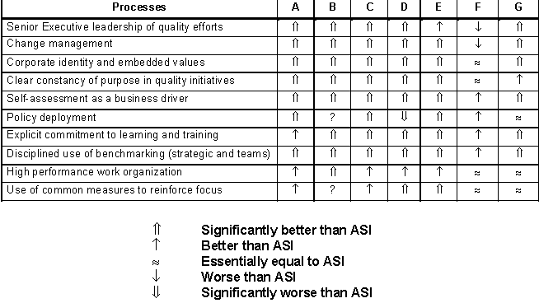

##### Advanced Charts

<http://peltiertech.com/Excel/Charts/NonNative.html>

|  |  |  |
| --- | --- | --- |
| Waterfall Chart | Marimekko Chart | Clustered and Stacked Column and Bar Charts. |
| Peltier Tech Cluster Stack Chart | Box and Whisker Diagrams (Box Plots) | Gantt Chart |

#### Functions

##### Ratio

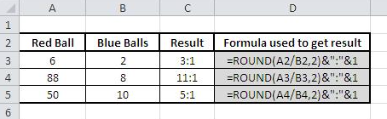

##### Data Validation

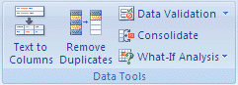

##### What-If Analysis

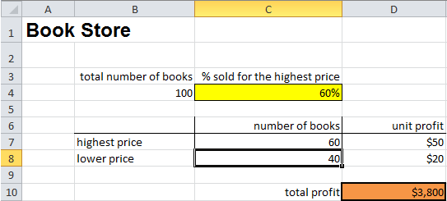

###### Scenario Manager

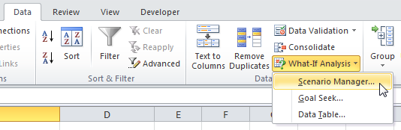

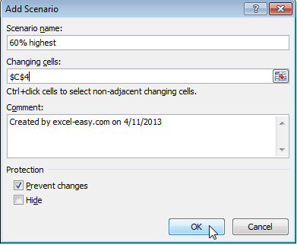

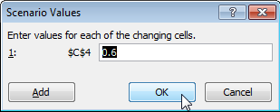

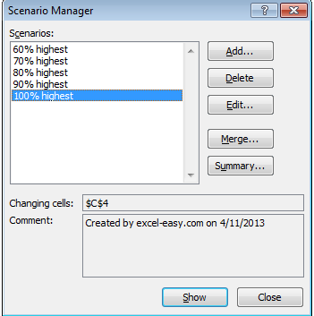

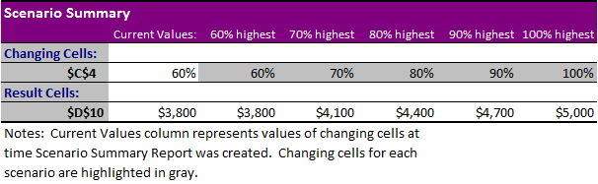

###### Goal Seek

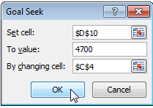

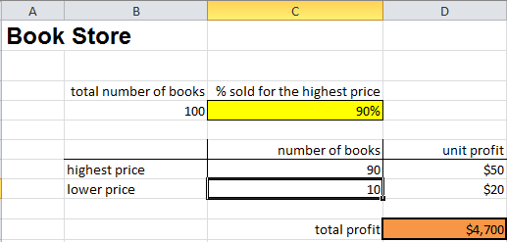

##### Solver Add-In

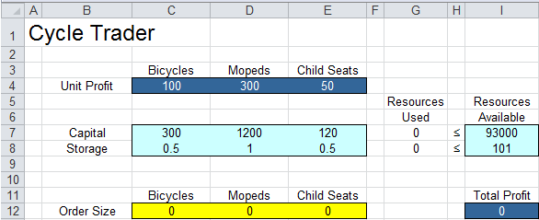

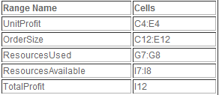

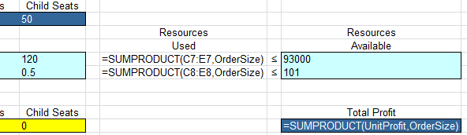

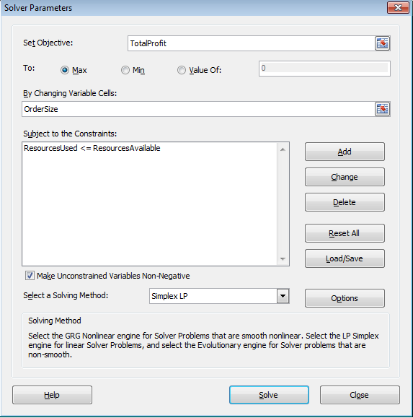

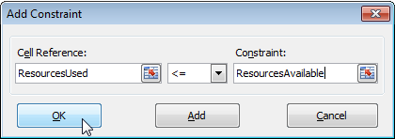

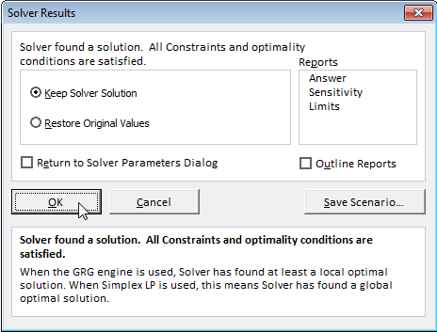

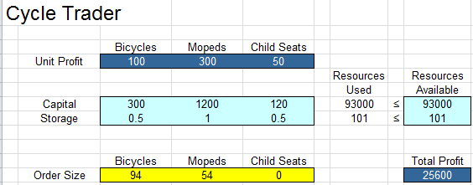

## Wealth Management

#### Components of Wealth Management Technology

➊Portfolio Management ➋Trading & Order Management ➌Transaction, settlement control & exception management ➍Fund accounting & record keeping ➎Performance & reporting ➏Data Management

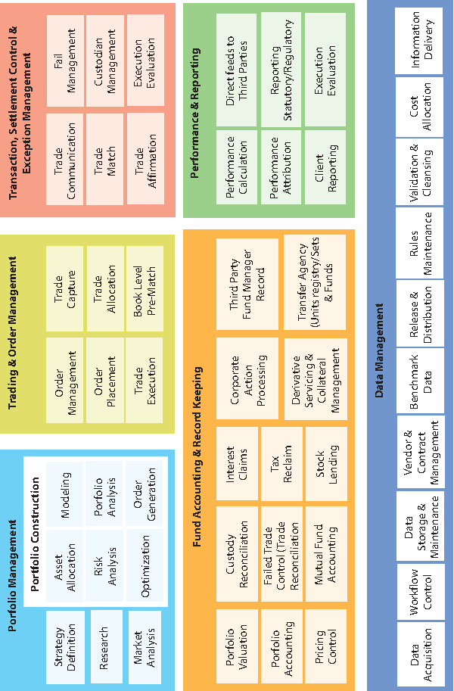

**Plan administration** ⬩Supports federal/ provincial regulation for *RRSP, RRIF, TFSA, RESP, RDSP* and non-registered plans **Term deposit manufacturing** ⬩Product manager can create/change products e.g. *Regular, Step Rate, Index Linked terms* **Savings account** ⬩Manages credits/debits flow through plan **Fund administration/ Unit holder recordkeeping** ⬩Funds processing & recordkeeping **Order management system + FundSERV interface** ⬩Process industry standard files & fund orders (initial order entry ⇨ reconciliation & settlement + non-financial messaging updates) ⬩High-volume, high-speed order placement and routing engine ⬩For fund manufacturer + distributor **Advisor inquiry** ⬩View transaction & client account-related information ⬩Reduces call center inquiries & costs for management company administrators **Fund distribution** ⬩5 components operating over a common database ⬩Designed for broker/ dealer investment fund distribution business **Fund accounting** ⬩Calculate / validate **daily fund unit prices (NAVs)** ⬩Integrated general ledger, multi-currency accounting, multi-class & multi-manager support, broad security coverage **Investment advisor/** **Practice management** ⬩View of book of business (recent contributions, new accounts opened, accounts in overdraft, expired trades & forthcoming maturities) ⬩Advisors track **Asset under Management (AUM)**, overall asset allocations / review transactions ⬩Subscribe to alerts (*accounts in overdraft, unacceptable drift from model or* ***IPS (Investment Policy Statement),*** *new accounts opened and ready for investment, new contributions, and transfers in/out)* **Client inquiry** ⬩View *client information (holdings, transactions, projected income and performance with drill down to account level or consolidate at the household level)* **Trade decision** ⬩**UMA/SMA rebalancing** **(Unified Managed account/Separately Managed account)** ⬩Overlay management techniques + discretionary model management + nondiscretionary trading strategies; trade worksheets, IPS drift monitoring + "quick trade" console **Portfolio management** ⬩**Front office functionality** (modeling, rebalancing, trading, order management, performance & reporting) ⬩**Back/ middle office functionalities** (fund valuation, G/L accounting, compliance, management fees, generic interfaces to other systems, support for managed account programs (SMA, UMA and model managed wrap accounts) ⬩**Investment advisory** to manage clients and book of business, functionalities (web-based sales tools, track **Anti-Money laundering AML,** **Know Your Customer KYC** + risk profiling metrics, generate investment policy statements, “What if” scenarios, Monte Carlo simulations + alternative investment scenarios) ⬩Advisors generate **Global Investment Performance Standards** **GIPS**-compliant performance reporting ⬩**Management fee rules** on (security list, asset class, contributions or trades, etc.)

#### Wealth Management Value Chain

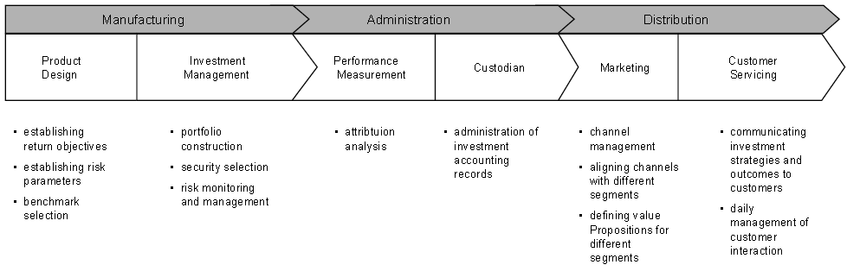

#### Schroders IT

⬩Achieved milestones from Target Operating Model (TOM) in operation aand administration platform centers ⬩Completed front-to-back-office investment I/F project ⇨ now possesses integrated technological platform with high degree of automated business flow as opposed to previously fragmented applications and solutions ⬩Remaining projects: strengthen client networking and communication links, improve global web content management and roll-out platform to investment centre ⬩As a result, efficiency increased and management of corporate data and securities registers rationalized

##### Front Office

⬩**CRIMS = main front office tool** ⬩Positions daily reconciled directly with **SimCorp Dimension (SCD)** - fund accounting tool and repository base ⬩Integrated order routing platform, live across international hubs and automatically performs compliance monitoring ⬩**Risk budgeting and portfolio construction** tools such as **PRISM** and **IMPACT** (equity), **FIA, Quick Risk** (fixed income) or **SMART** (multi-management side) fully integrated into CRIMS position-keeping reconciled with SCD ⇨Risk monitoring from various angles, including VaR calculations (for fixed income through Lehman Point), risk metrics for downside risks (e.g. expected shortfall or conditional VaR)

##### Middle & Back Office

⬩**Post-trading order processing**, use **FIX protocol** (broker communication/ confirmation), **Global Oasys** (trade matching for listed instruments), **Swapswire and DTCC** (confirmation for OTC) ⬩Communication + transaction flows with external depository banks and custodians follow standardized procedures based on **SWIFT** messages ⬩Custodian reconciliations for holdings and transactions automatically performed using **Intellimatch**

##### Data Management/Integration

Information stored in **Eagle PACE** (security master file, investment & benchmark data, account position) or **SCD** (portfolio data and position-keeping)

##### IT Security

⬩Outsourced to *CSC Computer Sciences Limited* for system security (database access and in-house and external firewall systems) and integrity and also to provide system maintenance routines ⬩All obligations governed by detailed SLAs ⬩Internally, 129 member IT specialist team to oversee internal proprietary system development and coordinates requests from various departments ⬩Business continuity procedures: dedicated staff monitoring, semi-annual updates, regular testing of communication plans and recovery sites ⬩Group-wide insurance covers revenue losses due to business interruptions

## Credit Card

##### Credit Card P/L

**Interest Reversal** = profit margins for servicing merchant processing of credit card payments are thin, and the competition is based on discount fees, support services, and the handling of charge backs (which are the reversals of charges). The issuing bank bills the cardholder for the full amount of the purchase and receives payment from the cardholder. The card association receives a small fee, usually around $0.05, for each transaction.

**Interchange fee** = market-based fee set by the credit card company that covers part of the cost of accepting credit cards. Interchange can vary by credit card Company (e.g. Visa, MasterCard), by retailer type, and by card type (regular, premium or commercial)

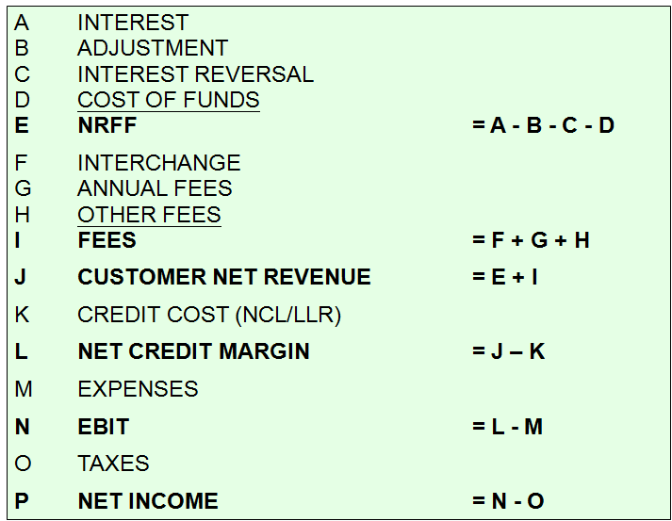

##### VISA

##### 

##### Operational framework

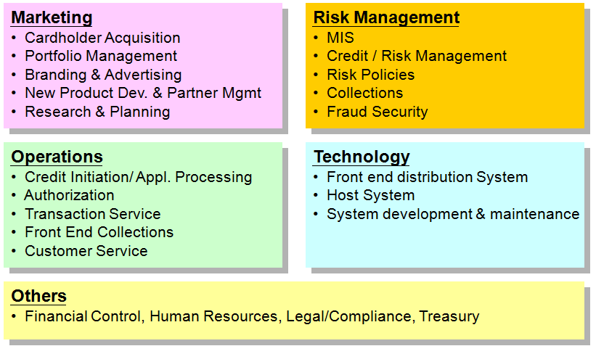

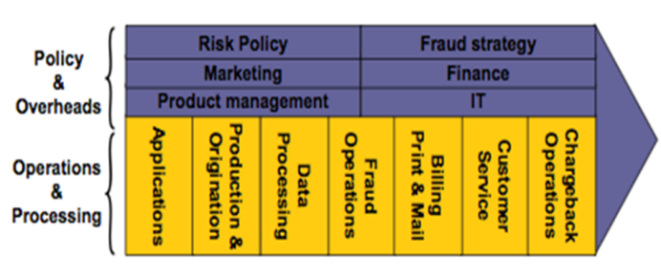

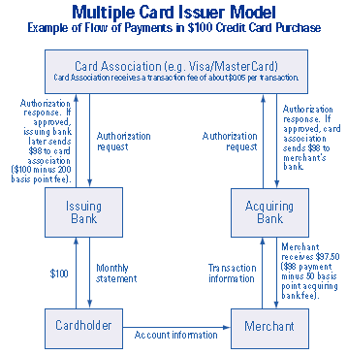

## CRM

##### SIEBELS CRM

⚫**Horizontal applications**: Siebel Sales, Siebel Call Center, Siebel Partner Portal, Siebel Remote ⚫**Industry applications**: Siebel Finance, Siebel Consumer Goods ⚫**Siebel User Interface UI**: High Interactivity (HI) mode (Active X controls for extra functionality), Standard Interactivity (SI) mode ⚫**Siebel Business Entities** Accounts, Activities, Assets,

Contacts, Households, Internal Products, Opportunities, and Service Requests

##### CRM Comparisons

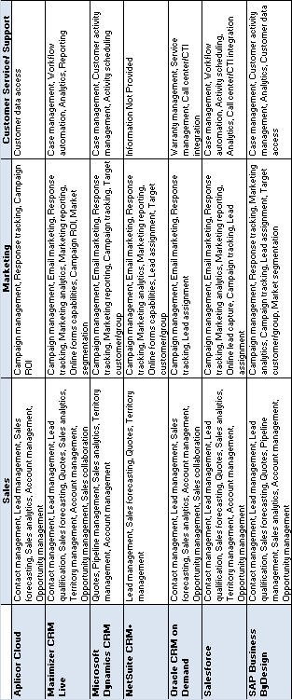

## HR Process and System

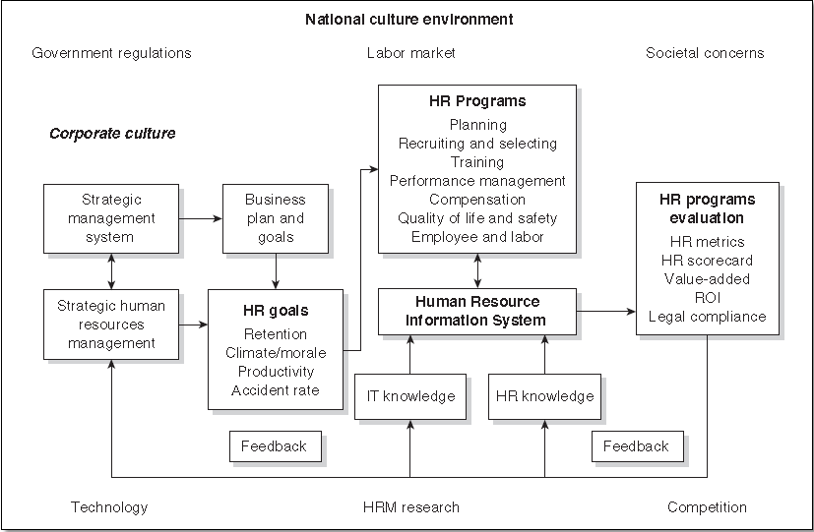

## Online brokerage

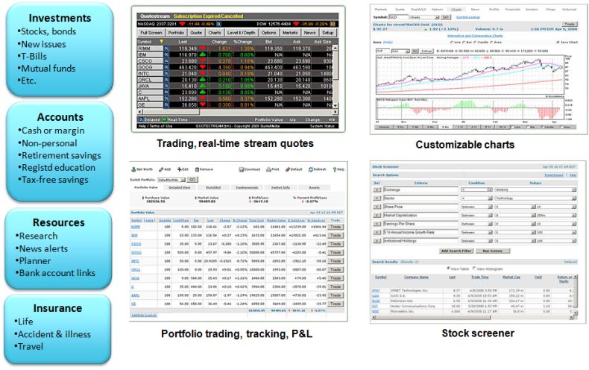

## ORACLE ERP Implementation Methodology

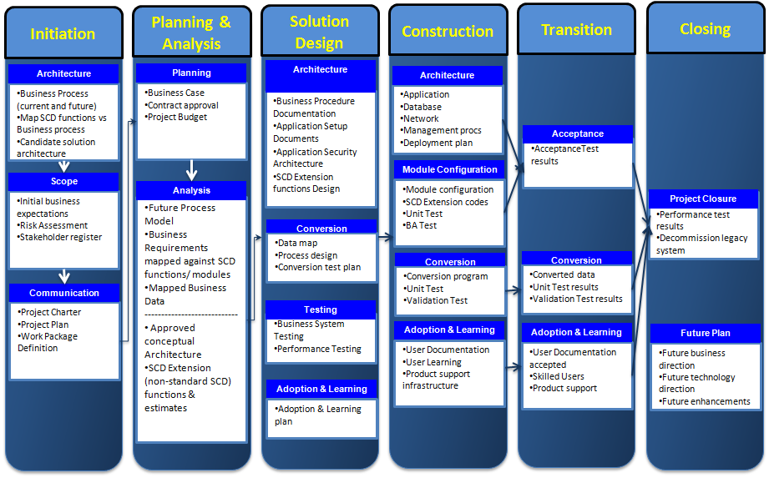

## COBIT 5

|  |  |
| --- | --- |
| COBIT 5 Principles  Governance & Management | Goals cascade |

#### Process for Governance

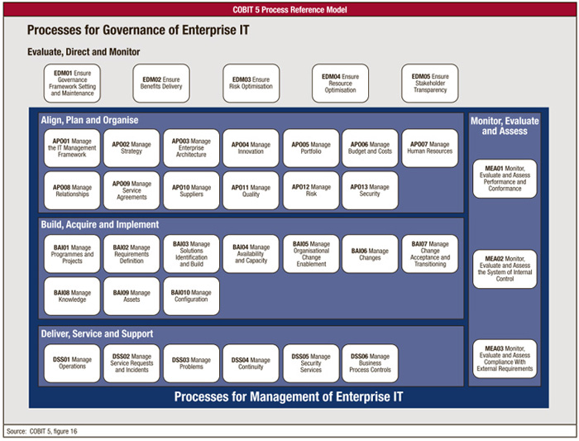

|  |  |
| --- | --- |
| Enablers | Enablers: Generic |

#### Seven Phases of Implementation

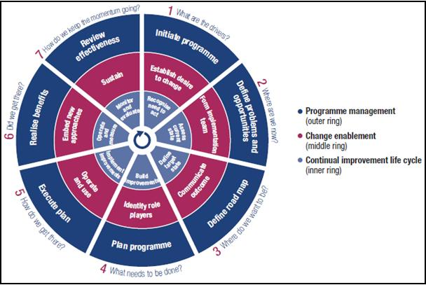

#### COBIT 5 Process Capability Model

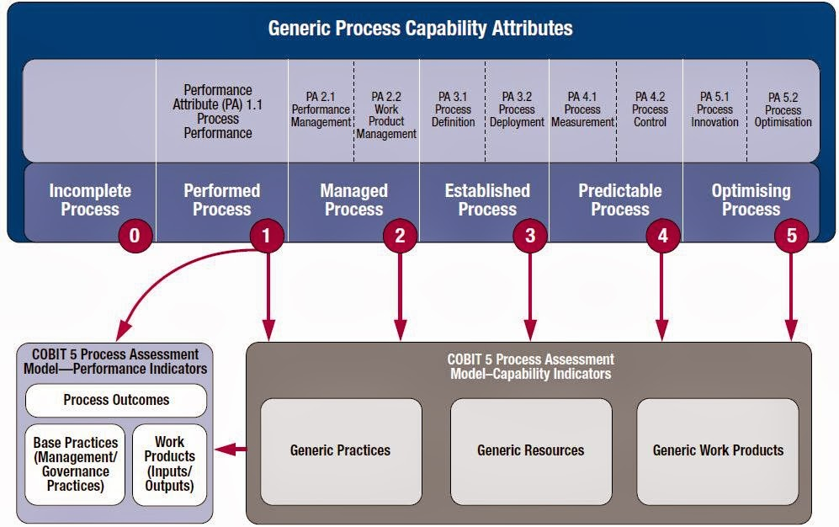

#### Risk Scenario Structure

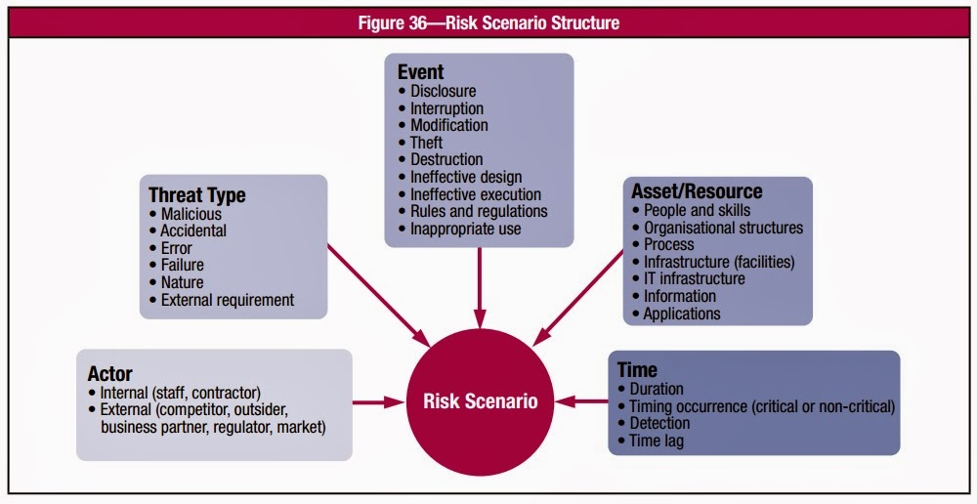

#### Risk Model

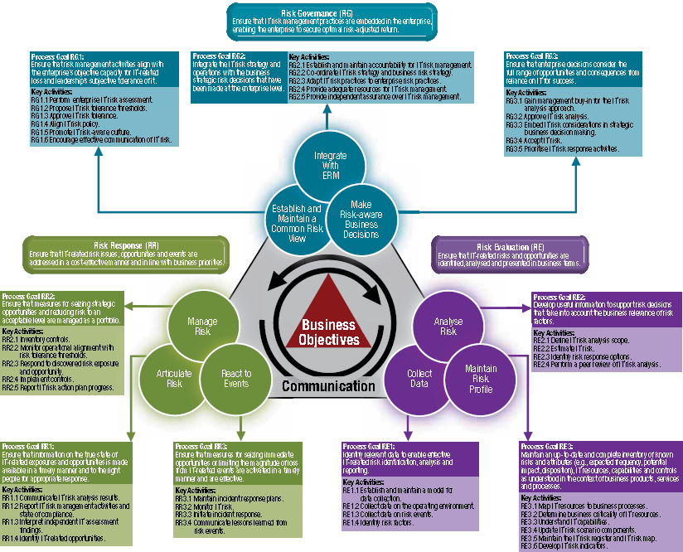

|  |  |
| --- | --- |
| IT Risk in the Risk Hierarchy | Risk Map and Risk Appetite |

See COBIT

|  |  |  |
| --- | --- | --- |
| Risk IT Principles | Elements of Risk Culture | IT Risk Scenario Components |

#### Risk Analysis & Response

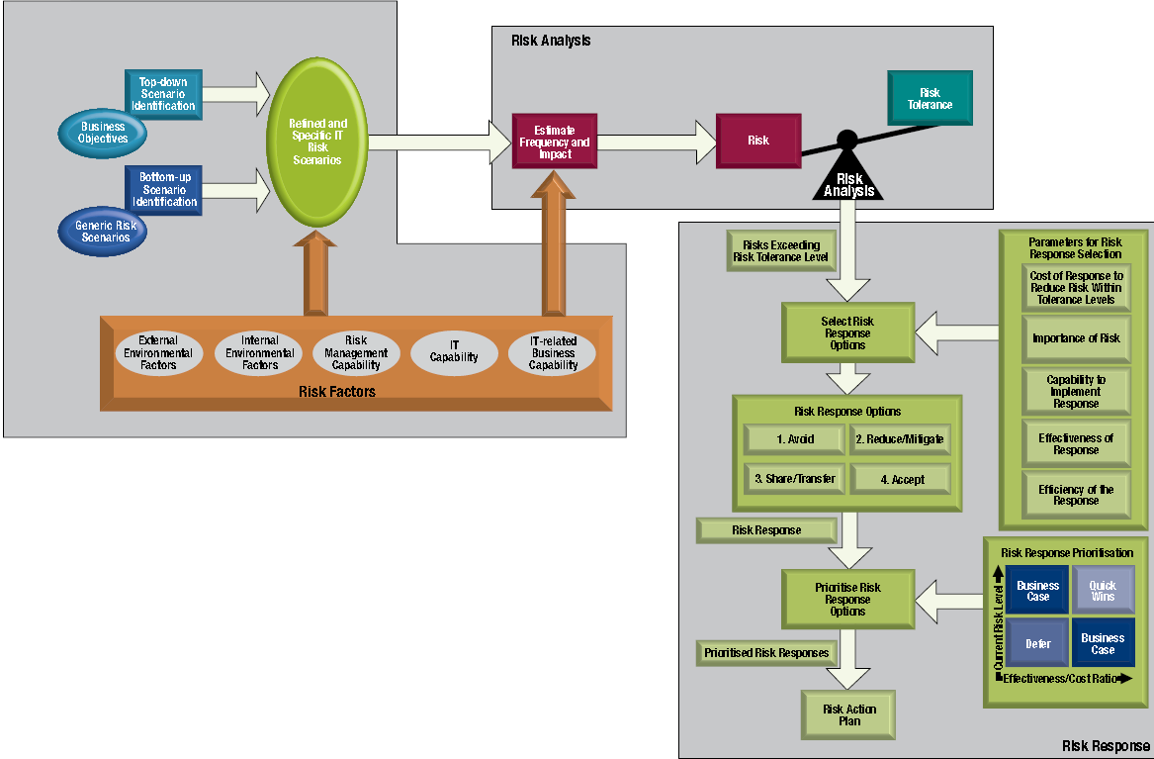

#### IT Risk Register

| **Template Risk Register Entry** | | | | | | | | | | | | | | | | |
| --- | --- | --- | --- | --- | --- | --- | --- | --- | --- | --- | --- | --- | --- | --- | --- | --- |
| **Part I—Summary Data** | | | | | | | | | | | | | | | | |
| **Risk statement** |  | | | | | | | | | | | | | | | |
| **Risk owner** |  | | | | | | | | | | | | | | | |
| **Date of last risk assessment** |  | | | | | | | | | | | | | | | |
| **Due date for update of risk assessment** |  | | | | | | | | | | | | | | | |
| **Risk category** | **🞏 Strategic**  **(IT benefit/value enablement)** | | | | | **🞏 Project Delivery**  **(IT program and project delivery)** | | | | | **🞏 Operational**  **(IT operations and service delivery)** | | | | | |
| **Risk classification (copied from risk analysis results)** | **🞏 Low** | | | **🞏 Medium** | | | | | **🞏 High** | | | | | **🞏 Very high** | | |
| **Risk response** | **🞏 Accept** | | | **🞏 Transfer** | | | | | **🞏 Mitigate** | | | | | **🞏 Avoid** | | |
| **Part II—Risk Description** | | | | | | | | | | | | | | | | |
| **Title** |  | | | | | | | | | | | | | | | |
| **High-level scenario (from list of sample high level scenarios)** |  | | | | | | | | | | | | | | | |
| **Detailed scenario description—scenario components** | Actor | |  | | | | | | | | | | | | | |
| Threat type | |  | | | | | | | | | | | | | |
| Event | |  | | | | | | | | | | | | | |
| Asset/resource | |  | | | | | | | | | | | | | |
| Timing | |  | | | | | | | | | | | | | |
| **Other scenario information** |  | | | | | | | | | | | | | | | |
| **Part III—Risk Analysis Results** | | | | | | | | | | | | | | | | |
| **Frequency of scenario (# times per year)** | **0** | **1** | | | **2** | | | **3** | | | | **4** | | | | **5** |
| **N≤0.01**  **🞏** | **0.01<N≤0.1**  **🞏** | | | **0.1<N≤1**  **🞏** | | | **1<N≤10**  **🞏** | | | | **10<N≤100**  **🞏** | | | | **100<N**  **🞏** |
| **Comments on frequency** |  | | | | | | | | | | | | | | | |
| **Impact of scenario on business** | **0** | **1** | | | **2** | | | **3** | | | | **4** | | | | **5** |
| 1. **Productivity** | **Revenue loss over one year** | | | | | | | | | | | | | | | |
| **Impact rating** | **I≤0.1%**  **🞏** | **0.1%<I≤1%**  **🞏** | | | **1%<I≤3%**  **🞏** | | | **3%<I≤5%**  **🞏** | | | | **5%<I≤10%**  **🞏** | | | | **10%<I**  **🞏** |
| **Detailed description of impact** |  | | | | | | | | | | | | | | | |
| 1. **Cost of response** | **Expenses associated with managing the loss event (US $)** | | | | | | | | | | | | | | | |
| **Impact rating** | **I≤10k$**  **🞏** | **10k$<I≤100k$**  **🞏** | | | **100k$<I≤1M$**  **🞏** | | | **1M$%<I≤10M$**  **🞏** | | | | **10m$<I≤100M$**  **🞏** | | | | **100M$<I**  **🞏** |
| **Detailed description of impact** |  | | | | | | | | | | | | | | | |
| 1. **Competitive advantage** | **Drop in customer satisfaction ratings** | | | | | | | | | | | | | | | |
| **Impact rating** | **I≤0.5**  **🞏** | **0.5<I≤1**  **🞏** | | | **1<I≤1,5**  **🞏** | | | **1,57<I≤2**  **🞏** | | | | **2<I≤2,5**  **🞏** | | | | **2,5<I**  **🞏** |
| **Detailed description of impact** |  | | | | | | | | | | | | | | | |
| 1. **Legal** | **Regulatory compliance—Fines (US $)** | | | | | | | | | | | | | | | |
| **Impact rating** | **None**  **🞏** | **< 1m$**  **🞏** | | | **<10m$**  **🞏** | | | **<100M$**  **🞏** | | | | **<1B$**  **🞏** | | | | **>1B$**  **🞏** |
| **Detailed description of impact** |  | | | | | | | | | | | | | | | |
| **Overall Impact rating (average of four impact ratings)** |  | | | | | | | | | | | | | | | |
| **Overall rating of risk, obtained by combining frequency and impact ratings on risk map** | **🞏 Low** | | | **🞏 Medium** | | | **🞏 High** | | | | | | **🞏 Very high** | | | |
| **Part IV—Risk Response** | | | | | | | | | | | | | | | | |
| **Risk response for this risk** | **🞏 Accept** | | | **🞏 Transfer** | | | | | **🞏 Mitigate** | | | | | | **🞏 Avoid** | |
| **Justification** |  | | | | | | | | | | | | | | | |
| **Detailed description of response (not in case of ‘accept’)** | **Response Action** | | | | | | | | | **Completed** | | | | | **Action Plan** | |
|  | | | | | | | | | **🞏** | | | | | **🞏** | |
|  | | | | | | | | | **🞏** | | | | | **🞏** | |
| **Overall status of risk action plan** |  | | | | | | | | | | | | | | | |
| **Major issues with risk action plan** |  | | | | | | | | | | | | | | | |
| **Overall status of completed responses** |  | | | | | | | | | | | | | | | |
| **Major issues with completed responses** |  | | | | | | | | | | | | | | | |
| **Part V—Risk Indicators** | | | | | | | | | | | | | | | | |
| **Key risk indicators** **(12) for this risk** | **1.**  ***2.***  ***3.*** | | | | | | | | | | | | | | | |

#### Risk Scenarios Template

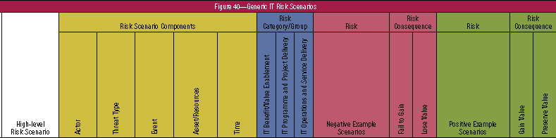

## CRISC 5 Practice Domains

Domain 1—Risk Identification, Assessment and Evaluation (31%) Domain 2—Risk Response (17%) Domain 3—Risk Monitoring (17%) Domain 4—Information Systems Control Design and Implementation (17%) Domain 5—IS Control Monitoring and Maintenance (18%) 🕮**IT Risk Management**

#### Domain 1—Risk Identification, Assessment and Evaluation

Identify, assess and evaluate risk to enable the execution of the enterprise risk management strategy.

|  |  |
| --- | --- |
| Domain 1—Task Statements **1.1** Collect information & review documentation to ensure that **risk scenarios** are identified and evaluated **1.2** Identify legal, regulatory and contractual requirements and organizational policies and standards related to information systems to determine their potential impact on the business objectives **1.3** Identify potential threats and vulnerabilities for business processes, associated data and supporting capabilities to assist in the evaluation of enterprise risk **1.4** Create and maintain a **risk register** to ensure that all identified risk factors are accounted for **1.5** Assemble risk scenarios to estimate the likelihood and impact of significant events to the organization **1.6** Analyze risk scenarios to determine their impact on business objectives **1.7** Develop a risk awareness program and conduct training to ensure that stakeholders understand risk and contribute to the risk management process and to promote a risk-aware culture **1.8** Correlate identified risk scenarios to relevant business processes to assist in identifying risk ownership **1.9** Validate **risk appetite and tolerance** with senior leadership and key stakeholders to ensure alignment | Domain 1—Knowledge Statements **1.1** Knowledge of standards, frameworks and leading practices related to **risk identification, assessment and evaluation** **1.2** Knowledge of techniques for risk identification, classification, assessment and evaluation **1.3** Knowledge of quantitative and qualitative **risk evaluation** methods **1.4** Knowledge of business goals and objectives **1.5** Knowledge of organizational structures **1.6** Knowledge of risk scenarios related to business processes and initiatives **1.7** Knowledge of business information criteria **1.8** Knowledge of **information systems architecture** (e.g. platforms, networks, application, databases and operating systems) **1.9** Knowledge of **information security** concepts **1.10** Knowledge of **threats and vulnerabilities** related to (**1.10** business processes and initiatives **1.11** third-party management **1.12** data management **1.13** system development life cycle **1.14** project and program management **1.15** business continuity and disaster recovery management **1.16** management of IT operations **1.17** emerging technologies) **1.18** Knowledge of the elements of a risk register **1.19** Knowledge of **risk scenario development tools & techniques** **1.20** Knowledge of risk awareness training tools and techniques **1.21** Knowledge of principles of risk ownership **1.22** Knowledge of current and forthcoming laws, regulations and standards |

#### Domain 2—Risk Response

Develop and implement risk responses to ensure that risk factors and events are addressed in a cost-effective manner and in line with business objectives

|  |  |
| --- | --- |
| Domain 2—Task Statements **2.1** Identify and evaluate risk response options and provide management with information to enable risk response decisions **2.2** Review risk responses with the relevant stakeholders for validation of efficiency, effectiveness and economy **2.3** Apply risk criteria to assist in the development of the risk profile for management approval **2.4** Assist in the development of risk response action plans to address risk factors identified in the organizational risk profile **2.5** Assist in the development of business cases supporting the investment plan to ensure risk responses are aligned with the identified business objectives | Domain 2—Knowledge Statements **2.1** Knowledge of standards, frameworks and leading practices related to risk response **2.2** Knowledge of risk response options **2.3** Knowledge of cost-benefit analysis and return on investment (ROI) **2.4** Knowledge of risk appetite and tolerance **2.5** Knowledge of organizational risk management policies **2.6** Knowledge of parameters for risk response selection **2.7** Knowledge of project management tools and techniques **2.8** Knowledge of portfolio, investment and value management **2.9** Knowledge of exception management **2.10** Knowledge of residual risk |

#### Domain 3—Risk Monitoring

Monitor risk and communicate information to the relevant stakeholders to ensure the continued effectiveness of the enterprise’s risk management strategy.

|  |  |
| --- | --- |
| Domain 3—Task Statements **3.1** Collect and validate data that measure key risk indicators (KRIs) to monitor and communicate their status to relevant stakeholders **3.2** Monitor and communicate key risk indicators (KRIs) and management activities to assist relevant stakeholders in their decision-making process **3.3** Facilitate independent risk assessments and risk management process reviews to ensure they are performed efficiently and effectively **3.4** Identify and report on risk, including compliance, to initiate corrective action and meet business and regulatory requirements | Domain 3—Knowledge Statements **3.1** Knowledge of standards, frameworks and leading practices related to risk monitoring **3.2** Knowledge of principles of risk ownership **3.3** Knowledge of risk and compliance reporting requirements, tools and techniques **3.4** Knowledge of key performance indicator (KPIs) and key risk indicators (KRIs) **3.5** Knowledge of risk assessment methodologies **3.6** Knowledge of data extraction, validation, aggregation and analysis tools and techniques **3.7** Knowledge of various types of reviews of the organization’s risk monitoring process (e.g. internal and external audits, peer reviews, regulatory reviews, quality reviews) |

#### Domain 4—Information Systems Control Design and Implementation

Design and implement information systems controls in alignment with the organization’s risk appetite and tolerance levels to support business objectives.

|  |  |
| --- | --- |
| Domain 4—Task Statements **4.1** Interview process owners and review process design documentation to gain an understanding of the business process objectives **4.2** Analyze and document business process objectives and design to identify required information systems controls **4.3** Design information systems controls in consultation with process owners to ensure alignment with business needs and objectives **4.4** Facilitate the identification of resources (e.g., people, infrastructure, information, architecture) required to implement and operate information systems controls at an optimal level **4.5** Monitor the information systems control design and implementation process to ensure that it is implemented effectively and within time, budget and scope **4.6** Provide progress reports on the implementation of information systems controls to inform stakeholders and to ensure that deviations are promptly addressed **4.7** Test information systems controls to verify effectiveness and efficiency prior to implementation  **4.8** Implement information systems controls to mitigate risk **4.9** Facilitate the identification of metrics and key performance indicators (KPIs) to enable the measurement of information systems control performance in meeting business objectives **4.10** Assess and recommend tools to automate information systems control processes **4.11** Provide documentation and training to ensure information systems controls are effectively performed **4.12** Ensure all controls are assigned control owners to establish accountability **4.13** Establish control criteria to enable control life cycle management | Domain 4—Knowledge Statements **4.1** Knowledge of standards, frameworks and leading practices related to information systems control design and implementation **4.2** Knowledge of business process review tools and techniques **4.3** Knowledge of testing methodologies and practices related to information systems control design and implementation **4.4** Knowledge of control practices related to business processes and initiatives **4.5** Knowledge of the information systems architecture (e.g., platforms, networks, application, databases and operating systems) **4.6** Knowledge of controls related to information security **4.7** Knowledge of controls related to third-party management **4.8** Knowledge of controls related to data management **4.9** Knowledge of controls related to the system development life cycle **4.10** Knowledge of controls related to project and program management **4.11** Knowledge of controls related to business continuity and disaster recovery management **4.12** Knowledge of controls related to management of IT operations **4.13** Knowledge of SW and HW certification and accreditation practices **4.14** Knowledge of the concept of control objectives **4.15** Knowledge of governance, risk and compliance (GRC) tools **4.16** Knowledge of tools and techniques to educate and train users |

#### Domain 5—IS Control Monitoring and Maintenance

Monitor and maintain information systems controls to ensure they function effectively and efficiently.

|  |  |
| --- | --- |
| Domain 5—Task Statements **5.1** Plan, supervise and conduct testing to confirm continuous efficiency and effectiveness of information systems controls **5.2** Collect information and review documentation to identify information systems control deficiencies **5.3** Review information systems policies, standards and procedures to verify that they address the organization's internal and external requirements **5.4** Assess and recommend tools and techniques to automate information systems control verification processes **5.5** Evaluate the current state of information systems processes using a maturity model to identify the gaps between current and targeted process maturity **5.6** Determine the approach to correct information systems control deficiencies and maturity gaps to ensure that deficiencies are appropriately considered and remediated **5.7** Maintain sufficient, adequate evidence to support conclusions on the existence and operating effectiveness of information systems controls **5.8** Provide information systems control status reporting to relevant stakeholders to enable informed decision making. | Domain 5—Knowledge Statements **5.1** Knowledge of standards, frameworks and leading practices related to information systems control monitoring and maintenance **5.2** Knowledge of enterprise security architecture **5.3** Knowledge of monitoring tools and techniques **5.4** Knowledge of maturity models - Knowledge of control objectives, activities and metrics related to (**5.5** IT operations and business processes and initiatives **5.6** Incident and problem management **5.7** architecture (platforms, networks, application, databases and operating systems) **5.8** information security **5.9** Third-party management **5.10** Data management **5.11** System development life cycle **5.12** Project and program management **5.13** Software and hardware certification and accreditation practices **5.14** Business continuity and disaster recovery management) **5.15** Knowledge of security testing and assessment tools and techniques **5.16** Knowledge of applicable laws and regulations |

## Information Security Management

#### SABSA Security Matrix

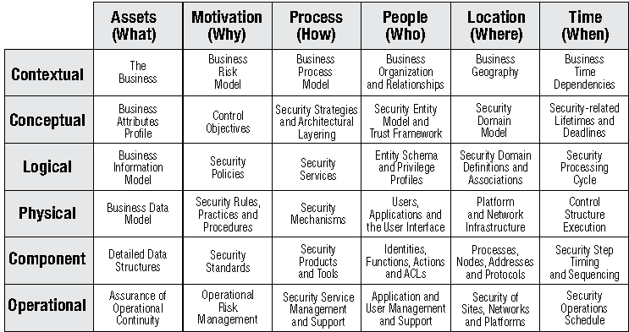

#### Defense in depth by Function

|  |  |  |  |
| --- | --- | --- | --- |
| **Defenses Against System Compromise** | **Policies, Standards, Procedures, Technology** | **Defenses Against System Compromise** | **Policies, Standards, Procedures, Technology** |
| **Prevention** | ⬩Authentication ⬩Authorization ⬩Encryption ⬩Firewalls ⬩Data labeling/handling/retention ⬩Management ⬩Physical security ⬩Intrusion prevention ⬩Virus scanning ⬩Personnel security ⬩Awareness and training | **Containment** | ⬩Authorization ⬩Data privacy ⬩Firewalls/security domains ⬩Network segmentation ⬩Physical security |
| **Detection/notification** | ⬩Monitoring ⬩Measurements/metrics ⬩Auditing/logging ⬩Honeypots ⬩Intrusion detection ⬩Virus detection | **Reaction Incident response** | ⬩Policy/procedure change ⬩Additional security mechanisms ⬩New/better controls |
| **Evidence collection/**  **event tracking** | ⬩Auditing/logging ⬩Management/monitoring ⬩Nonrepudiation ⬩Forensics | **Recovery/restoration** | ⬩Backups/restoration ⬩Failover/remote sites ⬩Business continuity/disaster recovery planning |

## Enterprise Architecture

#### TOGAF 9 Content Overview

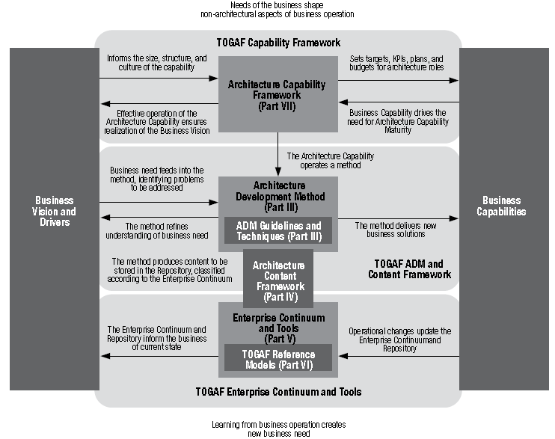

#### Architecture Development Method (ADM)

|  |  |
| --- | --- |
| **9 Phases 🄌**Preliminary Phase ➊ Requirements Management ➋Phase A:  Architecture Vision ➌Phase B:Business Architecture ➍Phase C:Information Systems Architectures ➎Phase D:Technology Architecture ➏Phase E:Opportunities & Solutions ➐Phase F:Migration Planning➑Phase G:Implementation Governance ➒Phase H:Architecture Change Management |  |

## Program Management Process (Ricardo Vargas)

|  |  |
| --- | --- |
|  |  |

## Traceability Matrix

|  |  |
| --- | --- |
|  |  |

## Benefits Realization

|  |  |  |  |  |  |  |  |
| --- | --- | --- | --- | --- | --- | --- | --- |
| **REALIZATION** | | | | **MONITORING** | | | |
| **BENEFIT ITEM** | **IMPACT** | **REALIZATION STRATEGY** | **DRIVER** | **MONITORING STRATEGY** | **START DATE** | **FREQUENCY** | **REVIEW BODY** |
| **Eliminate system unavailability during EOD processes** | Increased productivity | Usage of system during EOD processes | Channel Operations Manger | Conduct user satisfaction survey | Oct-13 | Monthly | GOTD -Snr General Manager |
| **Increase flexibility in product pricing** | Introduction of behavioral and risk based pricing | On going and introductory special offers to customers based on behavior and risk scores | Product Development and Portfolio Manager | Monthly report on accounts affected by product pricing changes | Oct-13 | Monthly | TCBD - General Manager / CRM- General Manager |
| **Improvement in fraud management capabilities** | Real-time monitor transactions, improve service to customers, reduce in fraud related losses | Usage of new fraud tools | Fraud Manager | Monthly reports on fraud cases | Oct-13 | Monthly | GOTD - Snr General Manager |
| **Core banking systems interfacing (e.g. FINACLE)** | Straight through processing of transactions across systems | Introduction of additional services to customer including standing order processing | Product Development, Portfolio Manager and Channel Operations Manger | Monthly report on transactions across systems | Oct-13 | Monthly | TCBD - Assistant General Manager / Snr General Manager |
| **Reward management** | Full loyalty strategy for multiple rewards + recognition programs | Introduction of integrated merchant and card holder rewards programs | Product Development and Portfolio Manager | Merchant and Card Holder rewards report | Oct-13 | Monthly | TCBD - Assistant General Manager / Snr General Mgr |
| **POS Inventory management** | Effective tracking & management of terminal inventory | Account for terminals using new system | Product Development and Portfolio Manager | Monthly POS terminal location report | Oct-13 | Monthly | TCBD - Assistant General Manager / Snr General Mgr |
| **Portfolio management** | Improved Analytics Capabilities | Effectively analyze key metrics to inform business strategic decisions | Product Development and Portfolio Manager | Monthly portfolio report on key metrics | Oct-13 | Monthly | TCBD - Assistant General Manager / Snr General Mgr |
| **Quickly modify or create products** | Ability to create or modify product in response to market changes | Introduce new products and modify existing product features | Product Development and Portfolio Manager | Track time is takes to develop or modify a product | Oct-13 | Monthly | TCBD - Assistant General Manager / Snr General Mgr |
| **Improvement in operating efficiency** | Increased productivity and reduction processing time | New system will handle processes that were previously handled manually | Operations Mangers | Conduct user satisfaction survey | Oct-13 | Quarterly | TCBD & GOTD - Assistant General Mgr / Snr Gen Mgr |
| **Incremental increase in revenue** | Increase in overall revenue | Monthly tracking and analysis | Business & Channel Analysts | Trial balance and Management reports | Oct-13 | Monthly | TCBD - Assistant General Manager / Snr Gen Manager |

## Managerial Tools, Techniques

|  |  |
| --- | --- |
| Constraint Analysis | Cause and Effect |
| Tornado Diagram | **Tornado diagrams** are useful for deterministic sensitivity analysis - comparing the relative importance of variables. For each variable/uncertainty considered, you will need estimates for what the low, base, and high outcomes would be. The sensitive variable is modeled as uncertain value while all other variables are held at baseline values (stable) |

|  |  |
| --- | --- |
| Check list  Influence DiagramRoot Cause Analysis  Probability and Impact Calculation  Probability and Impact Matrix  FMEA Diagram **FMEA** | Fault Tree Analysis  Risk Breakdown Structure  Decision Tree  Risk Heat Map |

#### DMAIC Tools Map

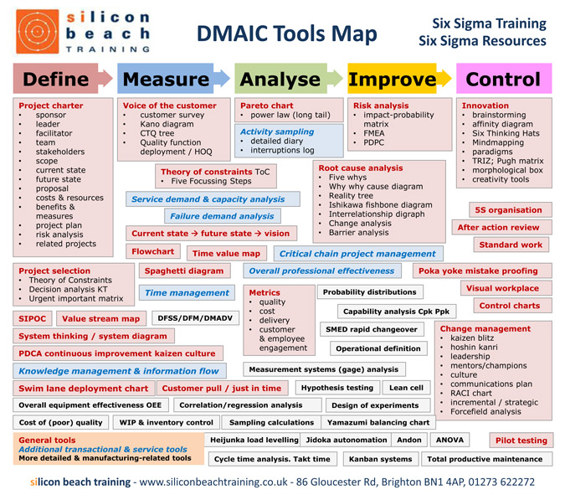

**ARIS Loves SIX SIGMA**

